Solution Intent

QB 9999 E1 111111 Project A Solution Intent

 | Date/Time Generated: | 2/12/2026 9:07:54 AM
 | Author: | SA Full Name

EA Repository : CTP_22_25
CREATED WITH | 

 | Solution Intent (SI)

SI Generated: 02/12/26
***ATTENTION: This Solution Intent (SI) should be validated by the Solution Architect to ensure requirements are still satisfied, if PI planning or phase 2 implementation begins after 08/12/26
It is Strongly encouraged to be reviewed with the Solution Architect if initial SI is being targeted in a later PI/release than initially planned.

QB 9999 E1 1111111 Project A Solution Intent

Version History
Version | Revision Date | Author / ATTUID | Notes
0.1 | 7/29/25 | SA / ATTUID | Phase 1 SI based on Epic Req 7/28/25 version (example only)
0.11 | 8/1/25 | SA / ATTUID | Revised Phase 1 SI based on Epic Req 8/1/25 adding new AC (example only)
0.2 | 9/5/25 | SA / ATTUID | Phase 2 SI - Draft (example only)
1.0 | 9/9/25 | SA / ATTUID | Phase 2 SI – Baselined (example only)
2.0 | 10/2/25 | SA / ATTUID | SI updates due to requirement changes: <Insert Summary of SI changes>  *Use this verbiage if requirement changes impacted SI.
Version 1.0 should represent the baselined version.
- Point Releases (ie 0.1) represent minor working version changes.
- Full Versions (ie 2.0) represent updates due to new requirements and should reference the new requirements.

Requirements
Summary: << Write a summary of the Epic requirement>> Do not use a full copy and paste (Copilot or LLM suggested for this).
<< Insert a link to your Epic's Business Requirements>>
If requirements change, summarize the changes in version history and increment the version. If the link to the requirements changes with the update, add additional links to the updated version and note the date.

Solution Overview
Write a concise executive summary (5 – 10 lines) describing what the solution is doing.

Alternative Solutions Considered
This should be some quick notes describing the alternatives (diagrams not necessary)

Assumptions, Constraints, Dependencies, and OOS
Type | Description
A-1
C-1
D-1
OOS-1

Applications Summary Table
Parent Package | Impact Type | MOTS ID | Application | IT App Owner | LoE
1111111 Development | Enhance | 11111 | Application A | mh3242 | Easy
1111111 Development | Enhance | 22222 | Application B | sk594e | Moderate
1111111 Non-Development | Test | 33333 | Application C | sp7463 | TestSupport
*Group impacts are added automatically via MDE and are not represented in the SI.

Product Team Summary Table
Product Team | Notes | MOTS ID | Application | Application LoE
Product Team A | Notes for work needed by Application A | 11111 | Application A | Easy
Product Team B | Notes for work needed by Application B | 22222 | Application B | Moderate
Product Team B | Notes for work needed by Application C | 33333 | Application C | TestSupport

Sequencing Summary Table
Parent Package | Application Impact Type | MOTS ID | Application | Application LoE | *Sequence
1111111 Development | Enhance | 11111 | Application A | Easy | A
1111111 Development | Enhance | 22222 | Application B | Moderate | B
1111111 Non-Development | Test | 33333 | Application C | TestSupport | C
*Sequences of "ZZZ" means the application was not considered in the sequencing.
This sequence table understands that this sequence does not cover all acceptance criteria or requirements or all scenarios under epic but covers most common and generic flow to give high level idea.
Actual development sequence should be relied on PI planning exercises.

Interfaces Summary Table
Source | Target | Name | Type | Description | Impact Type
Application A | Application B | Activate customer | mS | Details about this microservice | Enhance
Application C | Application B | Send customer data | API | Details about this API | Test
*Any Non-Backward compatible api design changes should be flagged for a risk assessment/validation by the api Provider with all api Consumers and SA/AA/SyE

Requirements Summary Table
NFR | Name | Notes | Apps
 | Requirement A | We need x to happen | Application A Application B
Y | Requirement B | Y will need to be available | Application C

QB 9999 E1 1111111 - Sales Order - Context
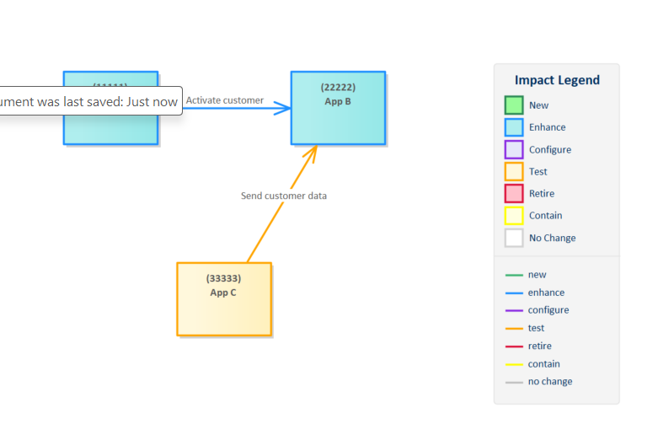
SI Created by: SA on 10/23/2025
Modified: 2/12/2026
Figure: 2

Diagram Notes here

---------------------------------------------------------------------------------------------------------------------------------------------------------------

1111111 Development

App A
Application Notes

Tagged Values
Application Name | App Lifestyle | App Lifestyle Status | Impact Type | LoE
Application A | Operational | In Use | New | Easy

Interfaces
Source | Target | Name | Type | Description | Impact Type
App A | App B | Activate customer | mS | Details about this microservice | Enhance

Requirements
Requirement | Requirement Details | Requirement App Notes | LoE
Requirement A | We need X to happen.

---------------------------------------------------------------------------------------------------------------------------------------------------------------

App B
Application Notes

Tagged Values
Application Name | App Lifestyle | App Lifestyle Status | Impact Type | LoE
Application B | Operational | In Use | Enhance | Moderate

Interfaces
Source | Target | Name | Type | Description | Impact Type
App A | App B | Activate customer | mS | Details about this microservice | Enhance
App C | App B | Send customer data | API | Details about this API | Test

Requirements
Requirement | Requirement Details | Requirement App Notes | LoE
Requirement A | We need X to happen.

1111111 Non-Development

App C
Application Notes

Tagged Values
Application Name | App Lifestyle | App Lifestyle Status | Impact Type | LoE
Application C | Operational | In Use | Test | TestSupport

Interfaces
Source | Target | Name | Type | Description | Impact Type
App C | App B | Send customer data | API | Details about this API | Test

Requirements
Requirement | Requirement Details | Requirement App Notes | LoE
Requirement C | Y will need to be available.

